|  |  |
| --- | --- |
| **COURSE CODE:** DJS22ITL502 | **DATE:** 21-10-24 |
| **COURSE NAME:** Advanced Data Structures Laboratory | **CLASS:** TY B. TECH |
| **NAME:** Anish Sharma **DIV:** IT1-1 | **ROLL:** I011 |

**EXPERIME NT NO. 8**

**CO/LO:** Choose appropriate data structure and use it to design algorithm for solving a specific problem

**AIM / OBJECTIVE:** To implement various operations on a Segment Tree.

**DESCRIPTION OF EXPERIMENT:**

**Properties of Segment Tree:**

Efficiency: O(log n) time for updates and queries.

Dynamic Updates: Supports efficient modifications of array elements.

Space: Requires O(4n) storage.

Range Queries: Handles various queries like sum, min, and max.

Non-Overlapping Segments: Each node represents a segment of the array.

**TECHNOLOGY STACK USED: C**

**CODE:**

|  |
| --- |
| #include <stdio.h>  #include <stdlib.h>    // Structure to represent the segment tree struct SegmentTree { int* tree; // Array to store segment tree int size; // Size of the segment tree  };    // Function declarations void buildSegmentTree(int* tree, int* arr, int start, int end, int node); int getSum(int* tree, int start, int end, int L, int R, int node); void update(int* tree, int start, int end, int index, int value, int node); struct SegmentTree* createSegmentTree(int* arr, int n); int rangeSum(struct SegmentTree* segTree, int L, int R, int n); void updateValue(struct SegmentTree* segTree, int index, int value, int n); void deleteValue(struct SegmentTree* segTree, int index, int n); void freeSegmentTree(struct SegmentTree* segTree);  // Function to create a segment tree from a given array struct SegmentTree* createSegmentTree(int* arr, int n) { |

|  |
| --- |
| struct SegmentTree* segTree = (struct SegmentTree*)malloc(sizeof(struct SegmentTree)); segTree->size = 4 * n; // Allocate enough space segTree->tree = (int*)malloc(segTree->size * sizeof(int)); buildSegmentTree(segTree->tree, arr, 0, n - 1, 0); return segTree;  }    // Function to build the segment tree void buildSegmentTree(int* tree, int* arr, int start, int end, int node) { if (start == end) { tree[node] = arr[start]; return;  } int mid = (start + end) / 2; buildSegmentTree(tree, arr, start, mid, 2 * node + 1); buildSegmentTree(tree, arr, mid + 1, end, 2 * node + 2); tree[node] = tree[2 * node + 1] + tree[2 * node + 2]; }    // Function to get the sum of a given range [L, R] int rangeSum(struct SegmentTree* segTree, int L, int R, int n) { return getSum(segTree->tree, 0, n - 1, L, R, 0);  }    // Helper function to get the sum int getSum(int* tree, int start, int end, int L, int R, int node) {  // If the range represented by a node is completely outside the given range if (start > R || end < L) { return 0;  }  // If the range represented by a node is completely inside the given range if (start >= L && end <= R) { return tree[node];  }  // Otherwise, the range is partially inside and partially outside int mid = (start + end) / 2;  return getSum(tree, start, mid, L, R, 2 * node + 1) + getSum(tree, mid + 1, end, L, R, 2 * node + 2); }    // Function to update a value in the array and the segment tree void updateValue(struct SegmentTree* segTree, int index, int value, int n) { update(segTree->tree, 0, n - 1, index, value, 0); }    // Helper function to update a value void update(int* tree, int start, int end, int index, int value, int node) { if (start == end) { |

|  |
| --- |
| tree[node] = value; return;  } int mid = (start + end) / 2; if (index <= mid) { update(tree, start, mid, index, value, 2 * node + 1);  } else { update(tree, mid + 1, end, index, value, 2 * node + 2);  } tree[node] = tree[2 * node + 1] + tree[2 * node + 2]; }    // Function to delete a value (set it to zero) in the array and segment tree void deleteValue(struct SegmentTree* segTree, int index, int n) { if (index < 0 || index >= n) { printf("Invalid index. Cannot delete.\n"); return;  }  // Set the value at the index to 0 update(segTree->tree, 0, n - 1, index, 0, 0);  }    // Function to free the segment tree void freeSegmentTree(struct SegmentTree* segTree) { free(segTree->tree); free(segTree);  }    // Menu-driven program int main() {  // int arr[] = {1, 3, 5, 7, 9, 11}; // int n = sizeof(arr) / sizeof(arr[0]); int a[10]; int n;  printf("Enter number of elements : "); scanf("%d",&n); for(int i=0 ; i<n;i++){ printf("Enter element : \n"); scanf("%d",&a[i]);  } struct SegmentTree* segTree = createSegmentTree(a, n);  int choice, L, R, index, value;  do { printf("\nMenu:\n"); printf("1. Query sum in range [L, R]\n"); printf("2. Update value at index\n"); printf("3. Delete value at index\n"); |
| printf("4. Exit\n"); printf("Enter your choice: "); scanf("%d", &choice);  switch (choice) { case 1:  printf("Enter range (L R): "); scanf("%d %d", &L, &R); if (L < 0 || R >= n || L > R) { printf("Invalid range. Please try again.\n");  } else { printf("Sum of values in range [%d, %d]: %d\n", L, R, rangeSum(segTree, L, R, n));  } break; case 2:  printf("Enter index to update: "); scanf("%d", &index); printf("Enter new value: "); scanf("%d", &value); if (index < 0 || index >= n) { printf("Invalid index. Please try again.\n");  } else { updateValue(segTree, index, value, n); printf("Value updated successfully.\n");  } break; case 3:  printf("Enter index to delete: "); scanf("%d", &index); deleteValue(segTree, index, n);  printf("Value deleted (set to zero) successfully.\n"); break; case 4:  printf("Exiting...\n"); break; default:  printf("Invalid choice. Please try again.\n");  }  } while (choice != 4);    freeSegmentTree(segTree); return 0;  } |

**OUTPUT:**

**Department of Information Technology**

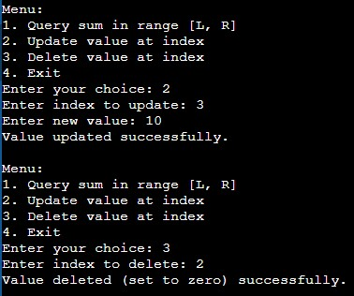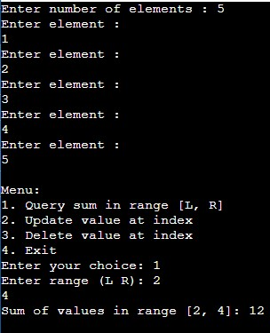

**CONCLUSION:** In this experiment we implemented variouus operations on a Segment Tree

**REFERENCES:**

1. Peter Brass, “Advanced Data Structures”, Cambridge University Press, 2008

Robert Sedgewick & Kevin Wayne, “Algorithms”, 4th Edition, Addison-Wesley Professional, 2011